Grade 7 Accelerated · Unit 6 · Lesson 5  Distance on the Coordinate Plane  Question Bank 6.05 | Name______________________  Date______________________  Period____________________

Show your work. Circle your final answer.
For questions 1 through 7, find the distance between the two points. Round to the nearest tenth when it is not a whole number.
1. 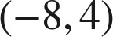 and 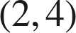

2. 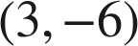 and 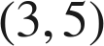

3. 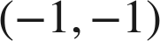 and 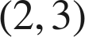

4. 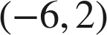 and 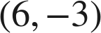

5. 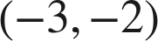 and 

6.  and 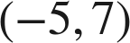

7. 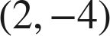 and 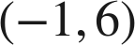

Choose one.
8. What is the distance between 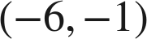 and 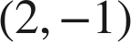?
○ A. 4
○ B. −8
○ C. 9
○ D. 8

9. Which gives the distance between 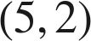 and 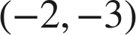?
○ A. 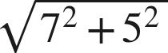
○ B. 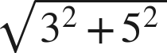
○ C. 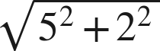
○ D. 